**LINUX NOTES**

**USER MANAGEMENT**

The user management that are used to manage the operating system on the needs of user and group

**USER 🡺** A person who utilizes the Operating System services is a user.

**GROUP 🡺** A group is collection of users.

**LINUX USER**

**Super user or root user(0) :**

This is the primary user with all permissions, access and privileges.

**Static system user(1-200) :**

The user created by Operating System automatically. Like daemon user or binary user.

**System user(201-999) :**

The user created when we install any package like DNS, HTTP(Apache) and chronyd because these services and daemons runs as a system user.

**Normal user(1000-60000) :**

Manually created users are normal user. Not having much privileges, access and permissions.

**cmd for main user and group administration files:**

* /etc/passwd
* /etc/group
* /etc/shadow
* /etc/gshadow

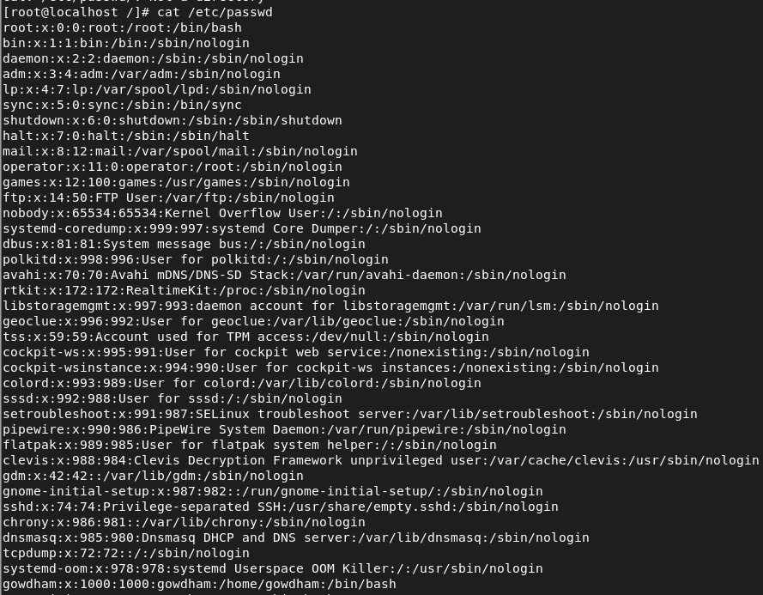

**/etc/passwd –**

Username:User's password mask : UID : GID : User Comment : home directory of user: Default log-in shell

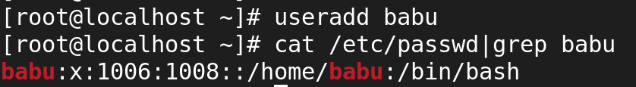

**/etc/group**



**/etc/shadow**

user:locked:Last password change:Minimum :Maximum :Warning days:Inactive:Expire:reserverd



**Set passwd and to viwe the passwd**

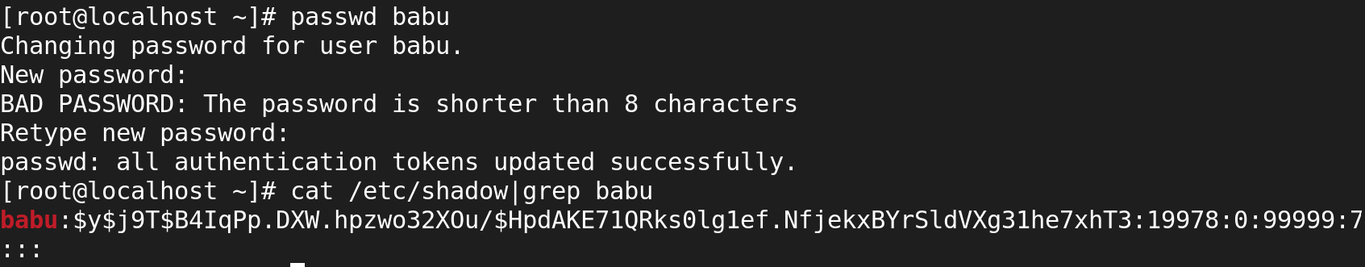

**/etc/gshadow**

Groupname:group password:group id admin:Members of group



**#ls -l /home**

**It is used to viwe the created user directory**

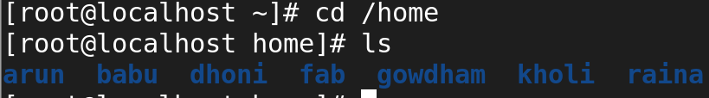

**#ls -l /var/spool/mail/**

**It is used to viwe for the every created user as a filetype.**

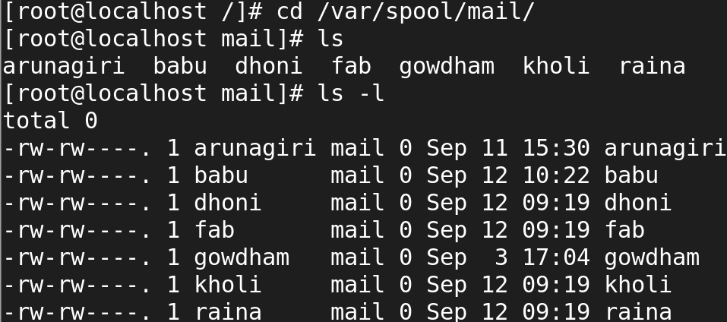

**CREATE AN USER ACCOUNT**

**#useradd username**

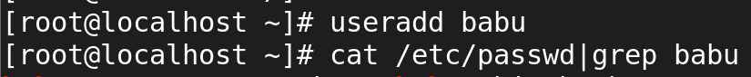

**To check the user's ID or UID with Group ID**

**#id username**



**To delete an user's account with its home directory and mail directory**

========================================================================

**#userdel --remove username**

**or**

**#userdel -r username**

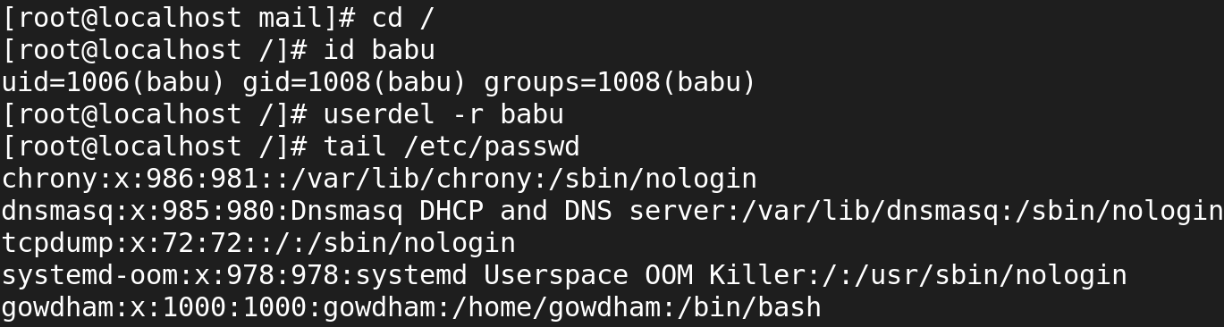

**To create group**

**#groupadd groupname**

**To see the information of groups**

**# cat /etc/group**

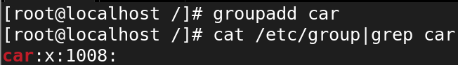

**Add user into a group**

**#gpasswd -a user group**

**or**

**#usermod -a -G group user**



**Remove user from a group**

**#gpasswd -d user group**

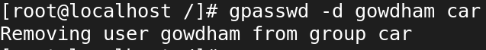

**To change ownership of file/folder**

**#chown username file/folder**

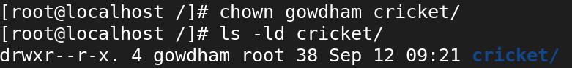

**To change group ownership of file/folder**

**#chgrp groupname file/folder**

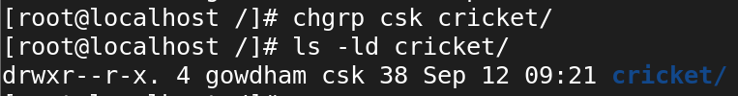

**To change ownership and group ownership of file/folder**

**#chown username:groupname file/folder**

**It is used to change ownership both the user and group ownership at single command.**

